**WEB DEVELOPMENT**

**A SUMMER INTERNSHIP REPORT**

**Submitted in the partial fulfillment of**

**Requirements to Summer Internship (CS- 451)**

**IV/IV B.Tech (VII Semester)**

**Submitted By**

**TULAM SAI SUDHEER (Y22CS184)**



**October, 2025**

**R.V.R. & J. C. COLLEGE OF ENGINEERING (Autonomous)**

**(Affiliated to Acharya Nagarjuna University)**

**Chandramoulipuram :: Chowdavaram**

**GUNTUR – 522019**

**CERTIFICATE**

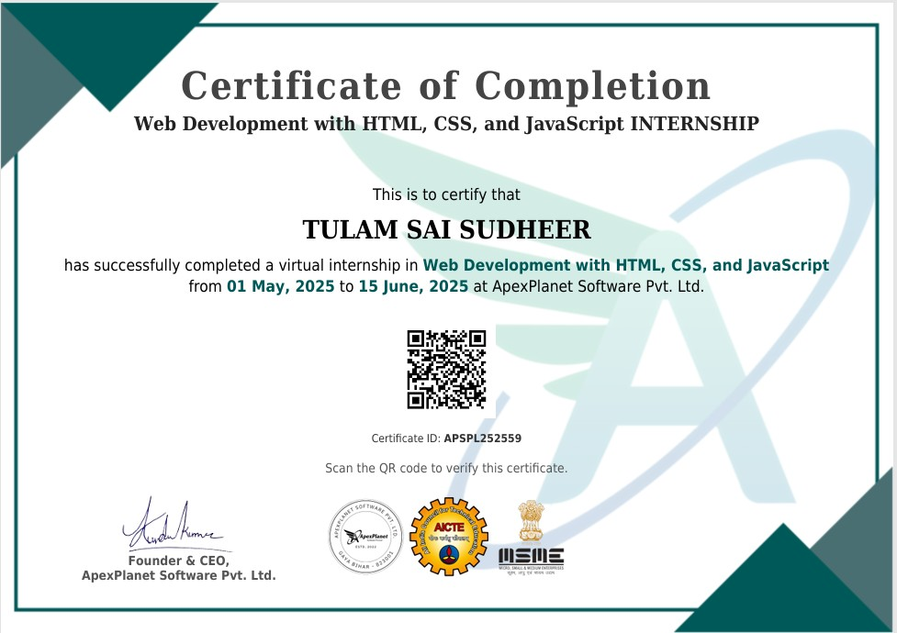

**ACKNOWLEDGEMENT**

The successful completion of any task would be incomplete without proper suggestions, guidance and environment. Combination of these three factors acts like backbone to our Internship **“Web Development with HTML,CSS and JavaScript”**

We would like to express our profound gratitude to **Dr.M.Sreelatha**, Head of the Department of Computer Science and Engineering and **Dr. Kolla Srinivas,** Principal, for their encouragement and support to carry out this Internship successfully.

We are very much thankful to **ApexPlanet Software Pvt.Ltd** ,for having allowed us to conduct the study needed for the Internship.

Finally we submit our heartfelt thanks to all the staff in the Department of Computer Science and Engineering and to all our friends for their cooperation during the Internship work.

**TULAM SAI SUDHEER (Y22CS184)**

**ABSTRACT**

This report presents the details of a virtual internship on **Web Development using HTML, CSS, and JavaScript**, successfully completed at **ApexPlanet Software Pvt. Ltd.** from **01 May 2025 to 15 June 2025**. The internship focused on gaining practical knowledge of front-end web technologies and their real-time applications in developing responsive and interactive web interfaces. Various projects such as a **Portfolio Website**, **Weather Application**, **Tic-Tac-Toe Game**, and **Calculator** were developed to demonstrate skills in web design, layout structuring, styling, and dynamic content manipulation using JavaScript. Through this internship, strong emphasis was placed on user interface design, responsive layouts, and efficient coding practices. The experience enhanced understanding of full stack concepts, project management, and problem-solving abilities. Overall, the internship provided valuable exposure to modern web development practices, improved technical proficiency, and contributed significantly to building a strong foundation for future software and full stack development projects.

**CONTENTS**

|  |  |  |  |  |
| --- | --- | --- | --- | --- |
|  |  |  |  | Page No. |
|  |  | Title Page | | i |
|  |  | Certificate | | ii |
|  |  | Acknowledgement | | iii |
|  |  | Abstract | | iv |
|  |  | Contents | | v |
|  |  | List of Figures | | vi |
|  |  |  | |  |
| 1 | Introduction | |  | 1 |
|  | 1.1 | Introduction to the<topic/concept of your project> | | 2 |
|  |  | 1.1.1 | <subtopic1> | … |
|  |  | 1.1.2 | <subtopic2> | … |
|  |  | 1.1.3 | <subtopic3> |  |
|  |  |  | … |  |
|  | 1.2 | Problem definition | |  |
|  | 1.3 | Significance of the work | |  |
| 2 | System Analysis | | |  |
|  | 2.1 | Requirements Specification | |  |
|  |  | 3.1.1 | Functional Requirements |  |
|  |  | 3.1.2 | Non-Functional Requirements |  |
| 3 | System Design | | |  |
|  | 3.1 | Architecture of the proposed system | |  |
|  | 3.2 | Workflow of the proposed system | |  |
|  | 3.3 | Module Description | |  |
| 4 | Implementation | | |  |
|  | 3.1 | Algorithms(Explanation compulsory) | |  |
|  | 3.2 | Data Sets/Data sources used | |  |
|  | 3.3 | Metrics calculated | |  |
|  | 3.4 | Methods compared | |  |
| 5 | ResultAnalysis | | |  |
|  | 5.1 | Actual Results obtained from the work(Include all plots) | |  |
|  | 5.2 | Analysis of the results obtained | |  |
| 6 | Conclusion and Future Work | | |  |
| 7 | References | | |  |

